Chapter 13, Problem 61.

For the circuit in Fig. 13.125 below, find I₁, I₂, and V_{o}.

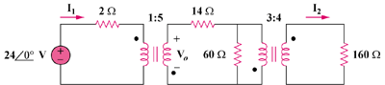

Figure 13.125
For Prob. 13.61.

